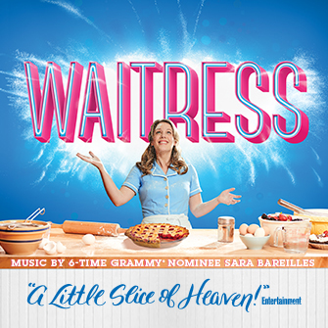

Inspired by Adrienne Shelly's beloved film, WAITRESS tells the story of Jenna - a waitress and expert pie maker, Jenna dreams of a way out of her small town and loveless marriage. A baking contest in a nearby county and the town's new doctor may offer her a chance at a fresh start, while her fellow waitresses offer their own recipes for happiness. But Jenna must summon the strength and courage to rebuild her own life.
*Contains Mature Content

Waitress
June 19-21, 2018
Sun | Mon | Tue | Wed | Thu | Fri | Sat
 |  | 19  7:30pm | 20  7:30pm | 21  7:30pm | 22  1:30pm  7:30pm | 23  1:30pm  7:30pm
24
1:30pm

Waitress
June 19-24, 2018

Tuesday, Wednesday, and Friday Matinee
Price Level | Full Price | Group (10+)
Premium | $99.00 | $89.10
A | $82.50 | $74.25
B | $71.50 | $64.35
C | $55.00 | $49.50
D | $44.00 | $39.60

Thursday and Friday Evening, Saturday Matinee, Sunday Matinee
Price Level | Full Price | Group(10+)
Premium | $115.50 | $103.95
A | $99.00 | $89.10
B | $88.00 | $79.20
C | $66.00 | $59.40
D | $55.00 | $49.50

Payment Policies and Procedure:

- Group minimum is 10.
- 25% is due within two (2) weeks of placing the reservation.
- Final payment is due 30 days prior to the show’s opening night performance.
- All groups have a one-time $10 processing fee.
- All sales are final. There are no exchanges or refunds given on group orders.
- Prices and performance schedules are subject to change without notice.

ORDER TODAY FOR THE BEST SEATS!
Call 817-212-4248
Email: groupsales@basshall.com

