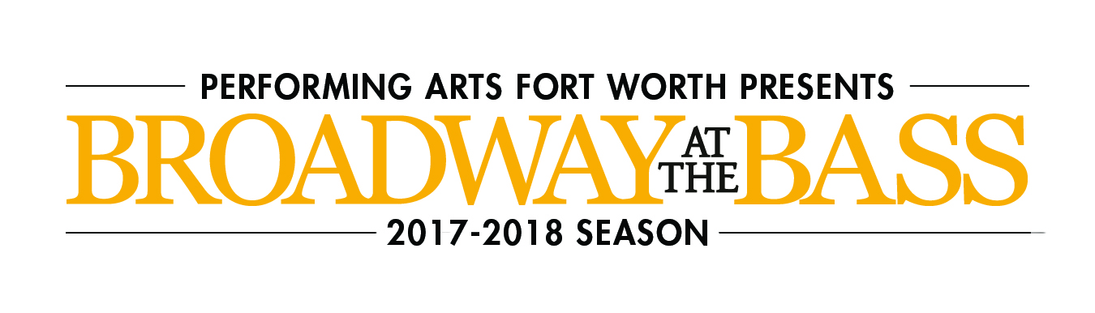

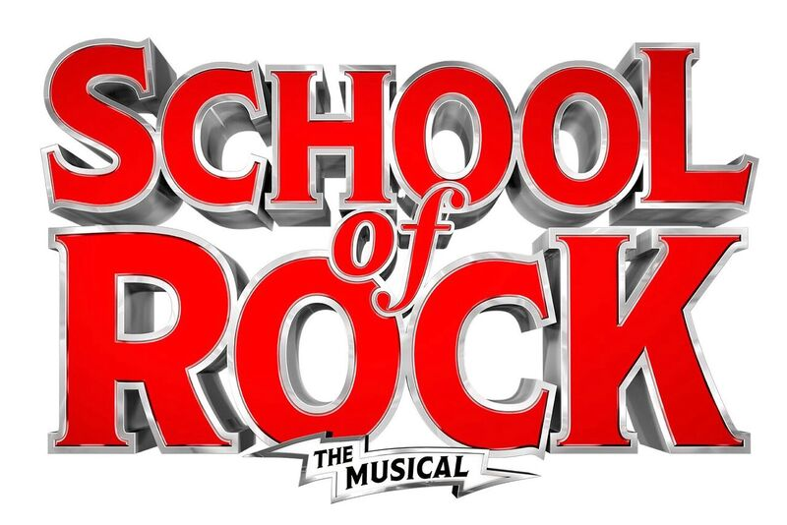

SCHOOL OF ROCK is a New York Times Critics’ Pick and “AN INSPIRING JOLT OF ENERGY, JOY AND MAD SKILLZ!” (Entertainment Weekly). Based on the hit film, this hilarious new musical follows Dewey Finn, a wannabe rock star posing as a substitute teacher who turns a class of straight-A students into a guitar-shredding, bass-slapping, mind-blowing rock band. This high-octane smash features 14 new songs from ANDREW LLOYD WEBBER, all the original songs from the movie and musical theater’s first-ever kids rock band playing their instruments live on stage. Vanity Fair raves, “FISTS OF ALL AGES SHALL BE PUMPING!”

School of Rock
Aug 28 – Sept 2, 2018
Sun | Mon | Tue | Wed | Thu | Fri | Sat
 |  | 28  7:30pm | 29  7:30pm | 30  7:30pm | 31  7:30pm | Sept 1  1:30pm  7:30pm
2
1:30pm
6:30pm

School of Rock
August 28-September 2, 2018

Tuesday, Wednesday, and Sunday Evening
Price Level | Full Price | Group (10+)
Premium | $99.00 | $89.10
A | $82.50 | $74.25
B | $71.50 | $64.35
C | $55.00 | $49.50
D | $44.00 | $39.60

Thursday and Friday Evening, Saturday Matinee, Saturday Evening, Sunday Matinee
Price Level | Full Price | Group(10+)
Premium | $115.50 | $103.95
A | $99.00 | $89.10
B | $88.00 | $79.20
C | $66.00 | $59.40
D | $55.00 | $49.50

Payment Policies and Procedure:

- Group minimum is 10.
- 25% is due within two (2) weeks of placing the reservation.
- Final payment is due 30 days prior to the show’s opening night performance.
- All groups have a one-time $10 processing fee.
- All sales are final. There are no exchanges or refunds given on group orders.
- Prices and performance schedules are subject to change without notice.

ORDER TODAY FOR THE BEST SEATS!
Call 817-212-4248
Email: groupsales@basshall.com

