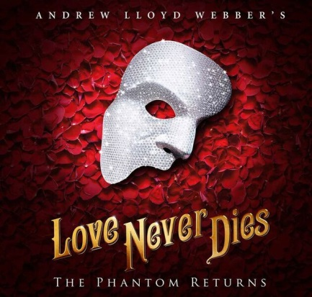
Don’t miss the magnificent continuation of one of the world’s greatest love stories with LOVE NEVER DIES, Andrew Lloyd Webber’s spellbinding sequel to The Phantom of the Opera. The year is 1907. It is 10 years after his disappearance from the Paris Opera House and the Phantom has escaped to a new life in New York where he lives amongst the screaming joy rides and freak shows of Coney Island. In this new, electrically charged world, he has finally found a place for his music to soar, but he has never stopped yearning for his one true love and musical protégée, Christine Daaé. In a final bid to win back Christine’s love, the Phantom lures her, Raoul and their young son from their home in Manhattan to the glittering and glorious world of Coney Island. “A masterpiece” - Sunday Express.
Love Never Dies
August 7-12, 2018
Sun | Mon | Tue | Wed | Thu | Fri | Sat
 |  | 7  7:30pm | 8  7:30pm | 9  7:30pm | 10  7:30pm | 11  1:30pm  7:30pm
12
1:30pm
6:30pm

Love Never Dies
August 7-12, 2018

Tuesday, Wednesday, and Sunday Evening
Price Level | Full Price | Group (15+)
Premium | $99.00 | $89.10
A | $82.50 | $74.25
B | $71.50 | $64.35
C | $55.00 | $49.50
D | $44.00 | $39.60

Thursday and Friday Evening, Saturday Matinee
Price Level | Full Price | Group(15+)
Premium | $115.50 | $103.95
A | $99.00 | $89.10
B | $88.00 | $79.20
C | $66.00 | $59.40
D | $55.00 | $49.50

Payment Policies and Procedure:

- Group minimum is 15.
- 25% is due within two (2) weeks of placing the reservation.
- Final payment is due 30 days prior to the show’s opening night performance.
- All groups have a one-time $10 processing fee.
- All sales are final. There are no exchanges or refunds given on group orders.
- Prices and performance schedules are subject to change without notice.

ORDER TODAY FOR THE BEST SEATS!
Call 817-212-4248
Email: groupsales@basshall.com

